Study Sheet SNC 1DI - Electricity Name: ______________________

Electrostatic Series

(weak hold on electrons) (+)

acetate

glass

wool

animal fur, human hair

calcium, magnesium, lead

silk

aluminium, zinc

cotton

paraffin wax

ebonite

polyethylene (plastic)

carbon, copper, nickel

rubber, sulphur

platinum, gold

(strong hold on electrons) (-)

If glass is rubbed with cotton, the ______________ will more likely lose its electrons because the ____________ holds its electrons tighter.

The glass will have a ______________ charge.  
The cotton will have a _____________ charge.

Static Electricity

Current Electricity

Three Laws Static Electricity

1.

2.

3.

Charging By Contact

Conductors/Insulators (Define and list Examples)

If an object is touched with a negative charge the object becomes _______________. (negative or positive)

If an object is touched with a positive charge the object becomes _______________. (negative or positive)

When charging an object by CONTACT the object obtains the ______________ (same or different) charge.

Conductors:

Insulators

Thunder and Lightning

How do clouds become charged?

What happens when the charge becomes too large?

What causes thunder?

How does a lightning rod work?

List some safety rules to follow during a thunderstorm?

Electrical Circuit Requirements

1. Energy **________ (cell or battery)**

**2. Load (resistor)**

**3. Control device or ____________**

**4. Connecting _________**

Reading Meters

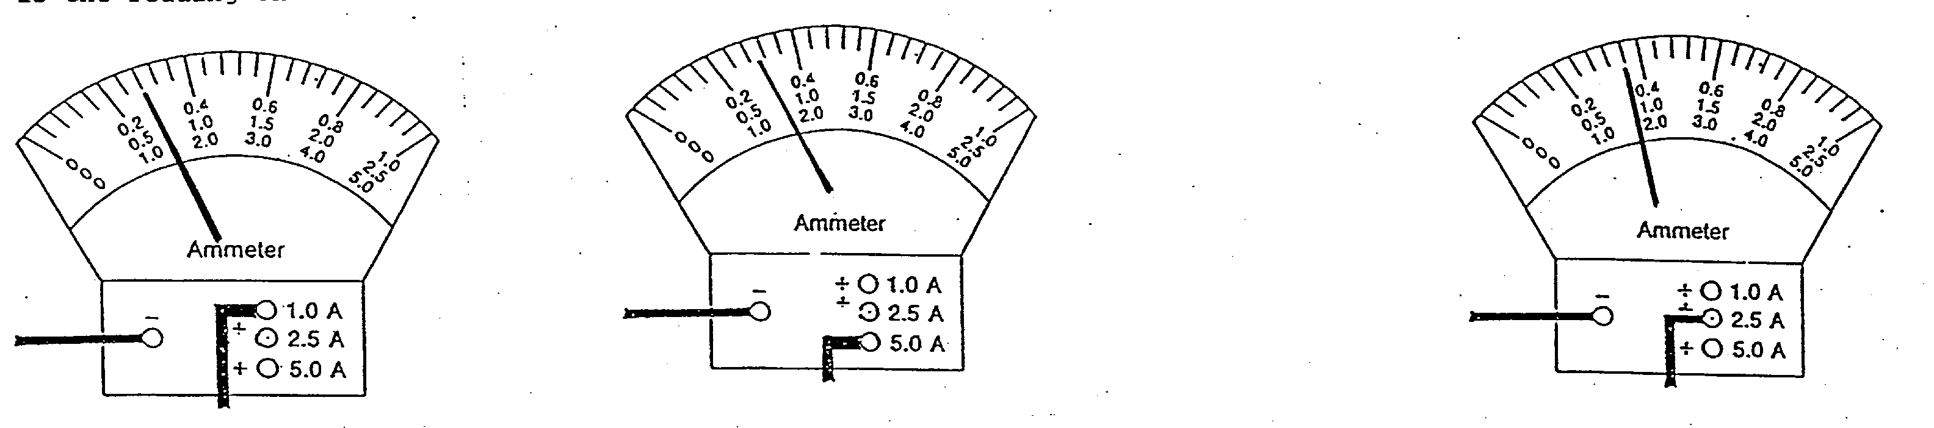

__________________ __________________ ____________________

Electricity Formulas: (Triangles!!)

Electricity Units and Symbols:

|  |  |  |
| --- | --- | --- |
| Electrical Terms | Letter in Triangle | Units of measurement |
| Potential-difference |  |  |
| Current |  |  |
| Resistance |  |  |
| Energy |  |  |
| Power |  |  |

Symbols for Schematic Drawings:

|  |  |
| --- | --- |
| Term | Symbol |
| Battery in series |  |
| Battery in parallel |  |
| Resistor |  |
| Fuse |  |
| Light bulb |  |
| ammeter |  |
| voltmeter |  |
| 120 V outlet |  |
| switch |  |
| ground |  |

Series and Parallel Circuits

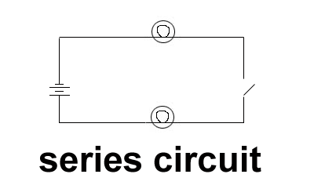

Electric circuits can be wired in **_________** or in **__________**.   
A **series** circuit only allows ______ path for the electrons to follow.

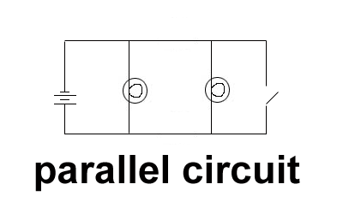

A **parallel** circuit has ______ than _____ path for the ___________ to follow and can have more than one electrical device.

Sample Questions:

1. Draw a circuit which has 5 cells (4V per cell) in series with 2 bulbs, each controlled by their own switch, and one motor that is in series. When one bulb goes out, the other bulb still works. An ammeter is located between the load and the source. Both bulbs have voltmeters measuring the energy across the load.

2. A TV uses 1500 W of power and has 5A of current flowing through it.   
 What is its potential difference (Voltage)?

3. A current of 12 A passes through an electric heater when it is connected to a 120 V power source. What is the heaters resistance?

4. Calculate the energy released (in Joules) from a 9 V battery that operated a smoke detector for   
 3.0 minutes. A current of 0.45 A flowed through the smoke detector.

5. Draw a **BEFORE, DURING, AND AFTER**, diagram of an electroscope, when an ebonite rod, that is rubbed with fur, is brought close to the ball but does **NOT** touch.

**BEFORE DURING AFTER**

**Type of Charging:________________________**

6. Draw a **BEFORE, DURING, AND AFTER**, diagram of an electroscope, when an ebonite rod, that is rubbed with fur, and makes contact with the metal ball.

**BEFORE DURING AFTER**

**Type of Charging:________________________**

7. With use of a diagram, show how lightning strikes the house on the ground.

