Extinction is Forever!

Many animals and plants have lost crucial habitat due to human activities. If an animal or plant is unable to adapt to new conditions, it will disappear from the Earth forever. This is known as extinction. Extinction will happen naturally; however, humans are speeding up this process at an alarming rate. There is something that can be done to slow down this process. If an animal is at serious risk of becoming extinct, it is called an endangered species. It is possible to protect organisms that are endangered and to allow their populations to increase, both in the wild, and in places like zoos. Sometimes species may be labeled as threatened, extirpated, or at-risk if their population is declining and they are at risk of becoming endangered.

Your task is to research an endangered species of animal or plant (Plants can go extinct too!) and to create a PowerPoint presentation to show to the class. Your organism should be from North America.

Some topic suggestions:
Peregrine flacon
Spotted turtle
Wolverine
Bald eagle
Grizzly bear
Prairie chicken
Grouse
Grey Whale
Whooping crane
Atlantic salmon
Beluga whale
Massassauga rattlesnake
Northern Leopard frog
Polar bear
Fringed bat
Southern flying squirrel
American chestnut Goldenseal

(visit http://www.sararegistry.gc.ca for more topic ideas)

Your presentation should include: Level

Description of your animal/plant 0 1 2 3 4
Where the organism lives 0 1 2 3 4
What the organism eats 0 1 2 3 4
Any predators of the organism 0 1 2 3 4
Food chain including the organism (use proper terminology) 0 1 2 3 4
What category is your organism? What does the term mean? 0 1 2 3 4
(endangered, threatened, extirpated, or at-risk)
Reasons that it is endangered (e.g.: poaching, habitat loss…) 0 1 2 3 4
How it is being protected 0 1 2 3 4
Research notes 0 1 2 3 4
Bibliography 0 1 2 3 4
(You MUST list your sources, with proper format!)
(A zero will be assigned for any project that does not have a proper bibliography!)
Quality of PowerPoint Presentation 0 1 2 3 4
Group Presentation Mark 0 1 2 3 4

Rough Notes and Bibliography due: _________________________
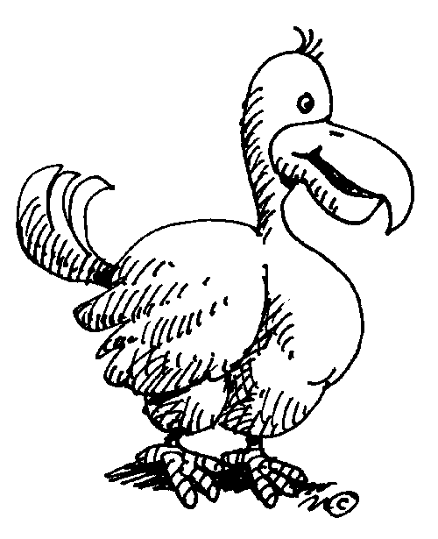

Presentations: ________________________________________

Comments:

