Name: ______________________________ Date: ___________________

Exam Diagram Review

BCI SCIENCE
SNC 2D

Chemistry:

- Draw a Bohr-Rutherford Diagram for
a) Calcium b) Nitrogen

- Using electron dot diagrams, show how

  - aluminum and oxygen bond to form aluminum oxide.

  - magnesium and phosphorus bond to form magnesium phosphide.

- Using electron dot diagrams, show how

a)carbon and oxygen bond to form carbon dioxide

b) sulphur and chlorine bond to form sulphur dichloride

Biology:

- Name the animal cell parts and functions.
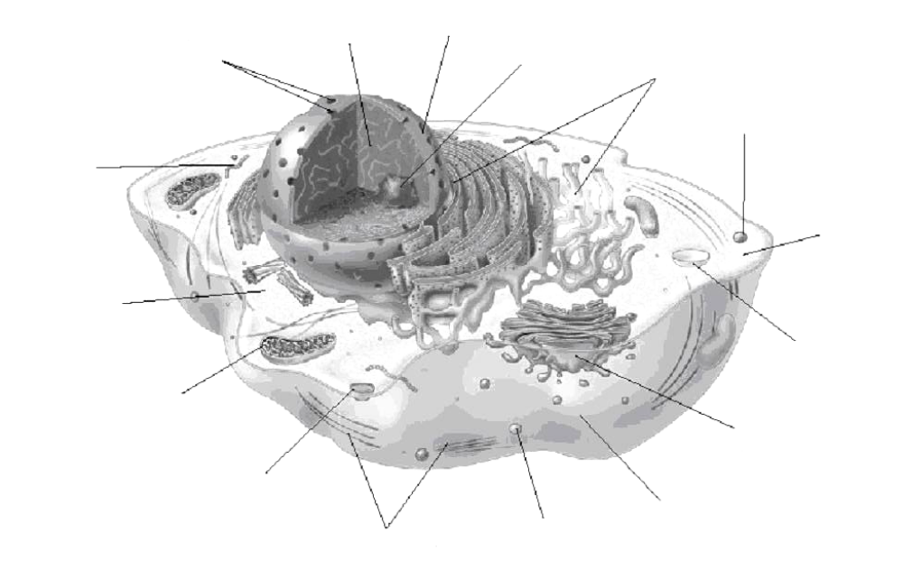

- Name the plant cell parts and functions.

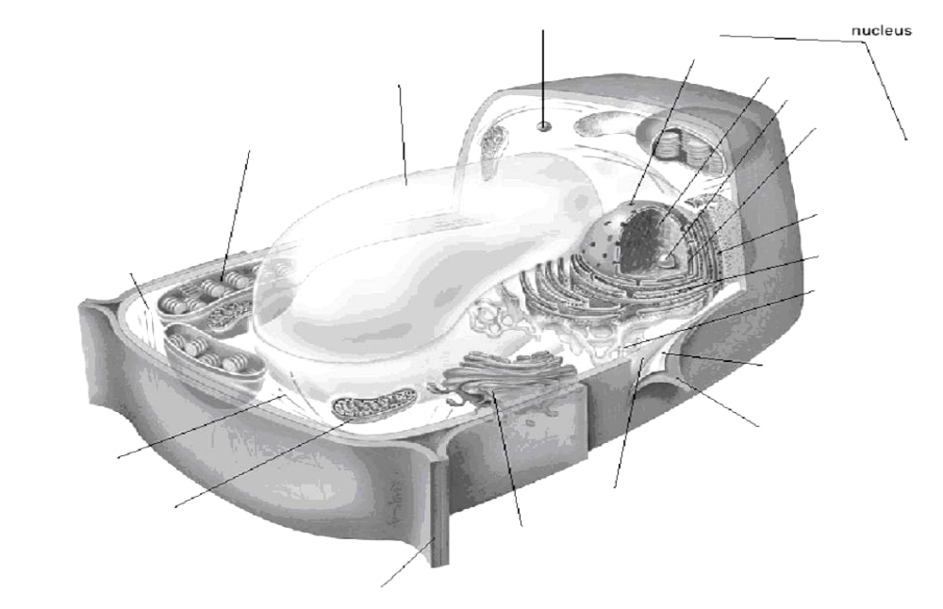

- Fully label the parts and functions of the compound microscope.

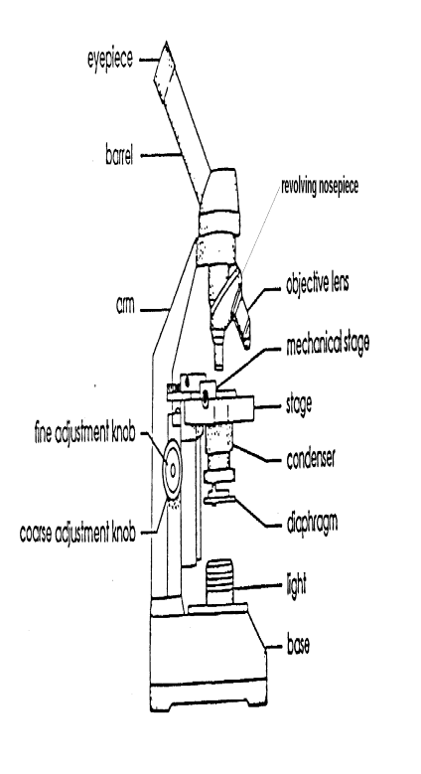

- Fully label the steps of MITOSIS and identify key features of each step
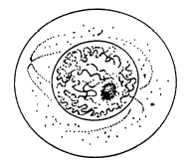
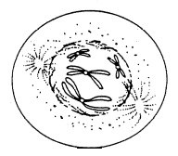
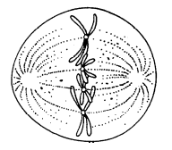
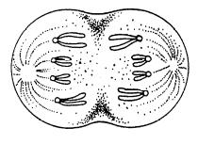
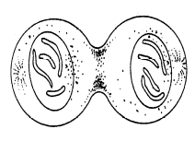

- Fully label all the parts and functions of the digestive system.
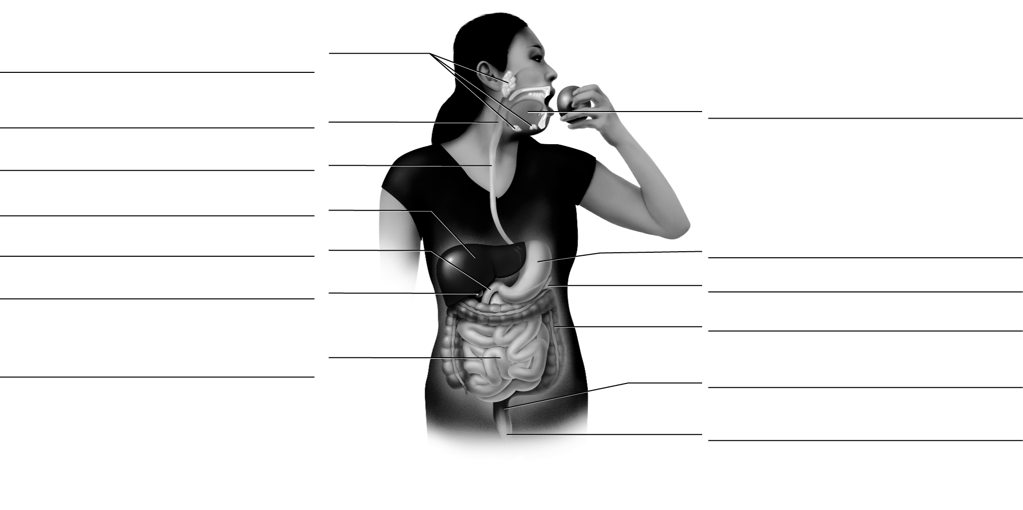

- Fully label all the parts and functions of the respiratory system.
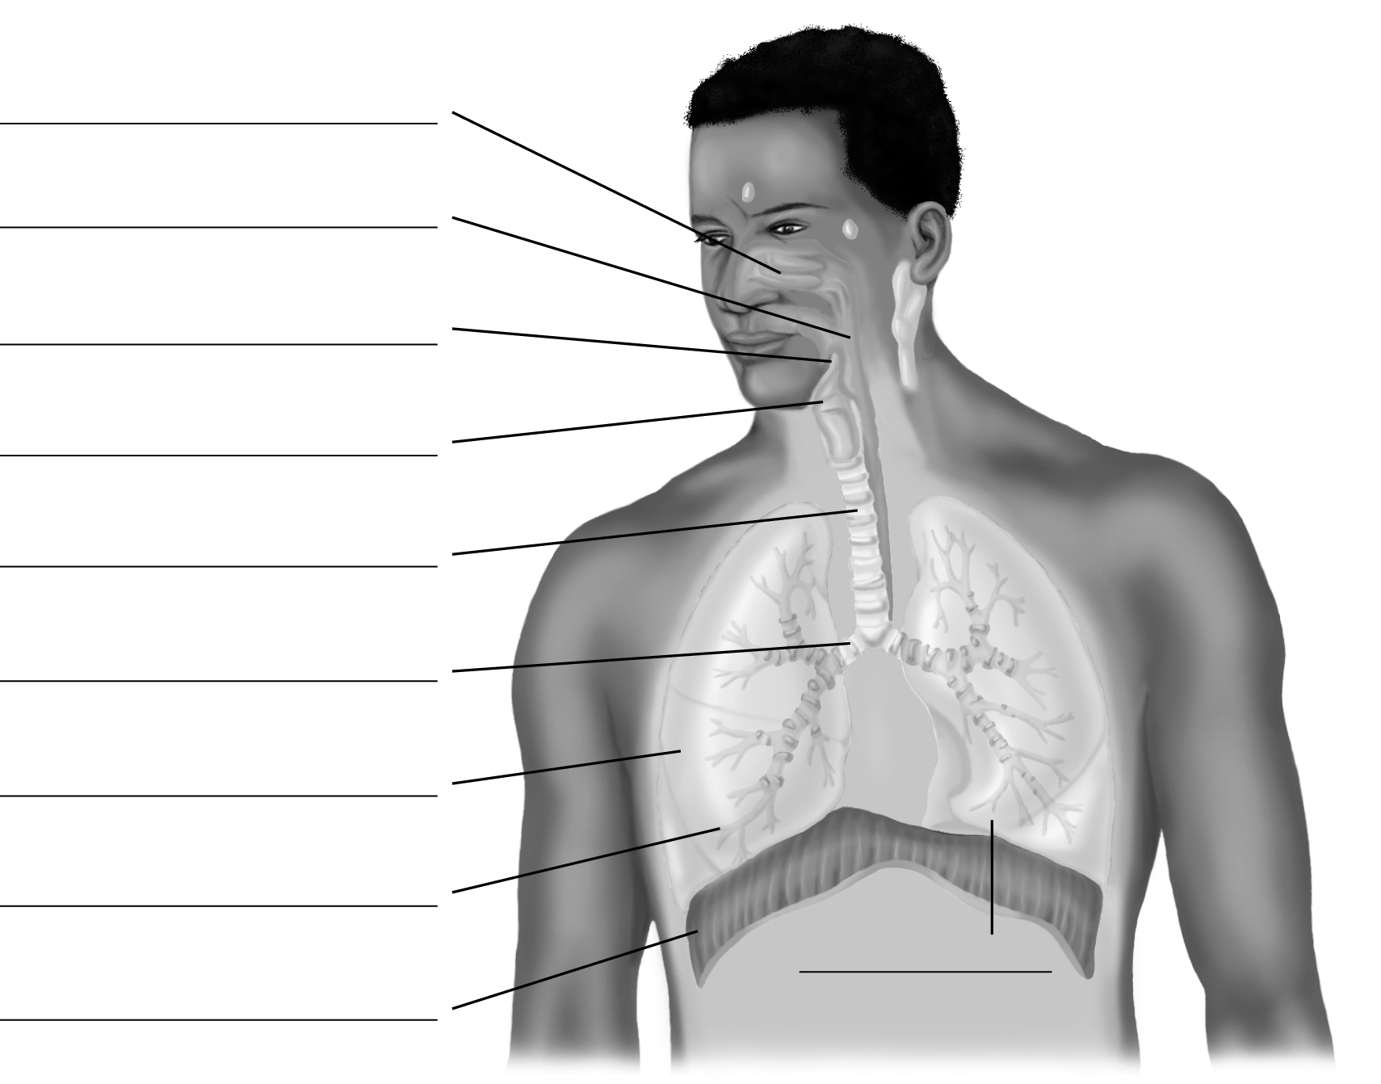

- Fully label the parts and functions of the human heart.

11. Fully label all the parts and functions of the frog.

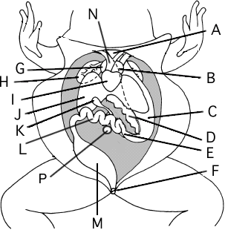

12. Be familiar with all the parts and functions of the worm
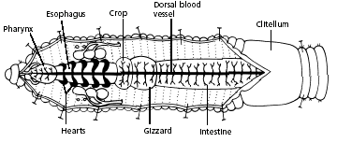

Optics:

- Using at least 3 rays, draw the image formed from the following object.


- Using 3 rays, draw and fully label the image formed in the following curved mirrors. Also complete a LOST table.















- Using 3 rays, draw the image formed from the lens and complete a LOST table
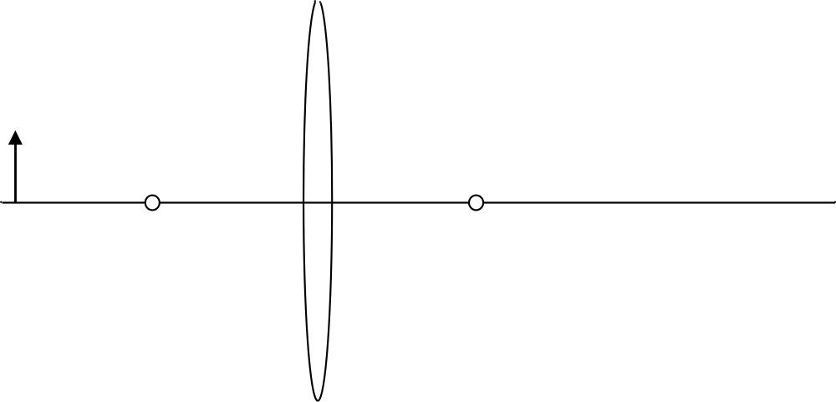

- Using 3 rays, draw the image formed from the lens and complete a LOST table

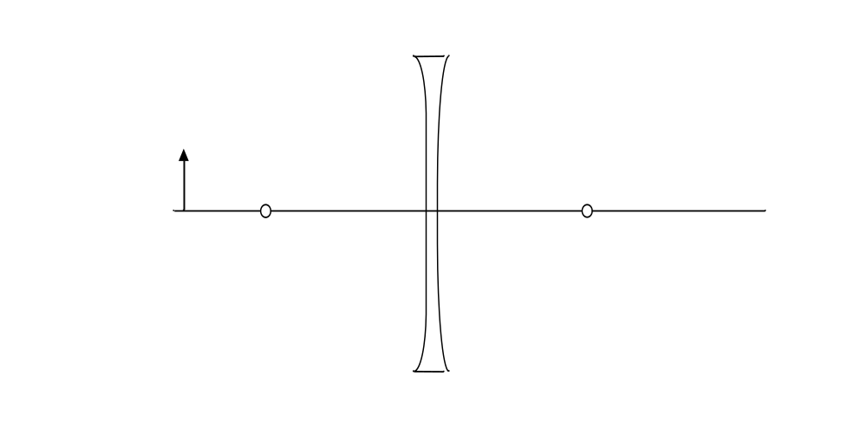

Study Tips for SNC2DI exam
Our exam is on _____________________ at 9:00 AM in our classroom

- Choose a good location – quiet, no distractions, resources available
- Spread out study time – little bursts over many days

Read your notes (don’t forget labs and assignments) and study your STUDY SHEETS/LEARING GOALS
- fill in the gaps
- Try to put it in your own words… it will be easier to remember
- See if you can explain a concept with a diagram

Think about what questions (m/c, matching, short answer) could be asked... can you answer them?

Practice without the answers visible!
- flash cards
- have someone quiz you (group study)

Re-write Quizzes
- These are a good indication of the important topics in each unit
- Clarify any wrong answers that you don’t understand

During Exam Review: bring questions to class
- Get specific help on what you need to learn... make it worth your while!

Before the Exam

- Finish your exam review package a minimum of 4 days prior to the exam
- Attempt the practice exam in exam-like conditions (calculator, ruler, PT, 1.5 hrs)
- Mark your practice exam a minimum of 3 days before the exam
- Correct any areas of need highlighted on the practice exam prior to the exam
- Pack your exam “gear” the night before (pencils, eraser, calculator, ruler, water bottle)
- Get a good night’s sleep!
- Eat a healthy breakfast
- Use the washroom before you start the exam

During the Exam
Read the whole question carefully!
- Underline/highlight key points

Time Management – look at the number of marks it is worth
Review your exam before you hand it in (if extra time)

Do the questions in any order you feel comfortable with (come back to it later!)

Write down what you know.

There will be no personal electronic devices, phones, jackets, or bags allowed at your desk during the exam

Exam mark = desired mark – (current mark x 0.7) x 100
30
Cheating or skipping the exam may result in not passing this course

