HEAT, TEMPERATURE, & THERMAL ENERGY

Energy – A property of matter describing the ability to do ______.

Work - is done when an object is moved through a distance by a force acting on the object.

Kinetic Energy – Associated with the _______ of an object.

Potential Energy – Stored energy due to an object’s _________.

Internal Energy – Sum of the kinetic and potential energies of the particles in a substance.

1st Law of Thermodynamics: The law of conservation of energy. Energy can be ____________ from one form to another but it cannot be created or destroyed.

Units of Energy: Joule (kg/m²/s²) or 1 calorie = _________

Heat energy (q) is the actual energy __________ between substances. i.e an object cannot possess heat

Why is heat energy essential in modern society?
i) Over 80% of the world's electricity is generated using heat.
ii) Heat energy is required to refine metals.
iii) Heat is required to both shape and weld pieces of metals.
iv) Heat produced by burning fuels operates many different kinds of engines.

The Kinetic Molecular Theory of Heat
Many theories have been developed in order to explain the concept of heat. The theory which appears to best explain heat is called the ____________________. This theory relates heat to the motion of particles. It is a combination of the ____________ and the _____________________________.

**The four main points of this theory are as follows: **
1. All matter is composed of many tiny particles called _______________.
2. The molecules are separated from one another by empty space. The ___________ ____________ the molecules is large ___________ to their ___________.
3. All molecules are _____________________ in some manner, and therefore possess ______________ energy (energy of motion).
4. When heat is added to matter, the molecules ___________ the energy and move __________ (their kinetic energy increases). When heat is ___________, the molecules ________ down (their kinetic energy decreases).

Temperature: A measure of the ___________________ of the molecules in a substance.
Thermal energy - is the total of the _______________ of the molecules (energy of motion) and the _________________(energy of the bonds holding the molecules together)
Systems: Substances in which a change (physical or chemical) occurs. i.e. reactants and products, represented by a chemical equation)
Surroundings: The rest of the universe! Usually the surroundings are considered to be anything nearby capable of absorbing or releasing thermal energy.
Endothermic: Process in which heat is ____________ by the system from the surroundings (____).
Exothermic: Process in which heat is ____________ from the system into the surroundings (____).
Open System: Both matter and energy can flow freely
Isolated System: Neither matter nor energy can flow freely (ideal but impossible)
Closed System: Energy can flow freely but not ___________
CHEMICAL ENERGY AND ENTHALPY CHANGE

Chemical systems include both kinetic and potential energy.
Kinetic Energies: Involved with the motion of particles.
- Electron movement within atoms
- Translation in gas and liquids, the movement of particles in a linear path
- Rotation about a bond axis
- Vibration, the oscillation of atoms connected by chemical bonds

Potential Energies: Involved with particles’ positions within an attractive or repulsive force field.
- Van der Walls Forces - Bond energy - Nuclear energy
- It is extremely difficult to measure the sum of all these kinetic and potential energies. Instead we study _______________________

Enthalpy Change (ΔH): The difference in enthalpies of reactants and products during a change. AKA heat of reaction ____________________
Hproducts > Δ Hreactants = + Δ H = _______________
Hreactants > Hproducts = - Δ H = _______________

Exothermic Reactions: Less energy is required to ________ bonds in the reactants than is ___________ by _____________ of new bonds in the products.
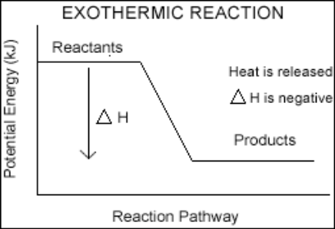
- The products of _________________ reactions have ____ stored potential energy than the reactants had (more energetically stable)

Endothermic Reaction: ______ energy is required to _______ bonds in the reactants than is released by formation of new bonds in the products.
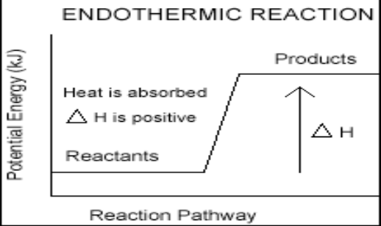
- The products of ______________ reactions have ______ stored potential energy than the reactants had (less energetically stable)
REPRESENTING ΔH
1. Thermochemical Equations with ΔH values:
E.g. 2Na(s) + 2 H₂O(l) ! 2NaOH(aq) + H₂(g) ΔH = -368.6 kJ
Remember:
a) ΔH is a “______________” property, it is affected by _______ and ________.
I.e. If a reaction produces water in the form of a gas or a liquid, the enthalpy change will be different since the enthalpy of liquid water is lower than the enthalpy of water vapour.
2H₂(g) + O₂(g)  2H₂O(l) ΔH°= -571.0 kJ 2H₂(g) + O₂(g)  2H₂O(g) ΔH°= -483.6 kJ
Scientists will often report results at _____ and use the symbol ΔH° to indicate that the value is the “standard enthalpy of reaction”.

b) Exothermic reactions in one direction, become endothermic reactions in the reverse direction. (I.e. change the sign of ΔH)
2H₂(g) + O₂(g)  2H₂O(g) ΔH°= -483.6 kJ 2H2O(g)  2H₂(g) + O₂(g) ΔH°= +483.6 kJ

c) The value of ΔH depends on the _____ amounts of reactants and products involved.
2H₂(g) + O₂(g)  2H₂O(l) ΔH°= -571.0 kJ
H₂(g) + 1/2O₂(g)  H₂O(l) ΔH = 1/2(-571 kJ) = -285.5 kJ

2. Thermochemical Equations with Energy Terms:
Endothermic (energy is absorbed) 2H₂O(g) + 483.6 kJ  2H₂(g) + O₂(g)
Exothermic (energy is released) 2H₂(g) + O₂(g)  2H₂O(g) + 483.6 kJ

3. Molar Enthalpies of Reaction:
The enthalpy change associated with 1 mole of a substance. The particular reactant or product must be specified.
2H₂(g) + O₂(g)  2H₂O(l) ΔH°= -571.0 kJ/mol O2
2H2(g) + O2(g)  2H2O(l) ΔH°= -285.5/mol H2
4. Potential Energy Diagrams:

Stoichiometry and Thermochemical Equations

The enthalpy of reaction is __________ dependent on the quantity of products.
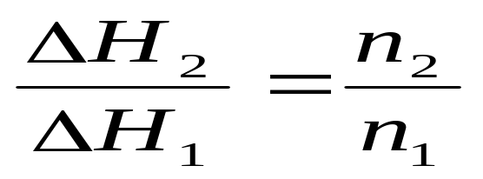

EXAMPLE:
1. What is the enthalpy change when 1.0 kg of Al reacts completely with excess Cl₂ according to the following equation?

2Al_{(s)} + 3Cl_{2(g)} → 2AlCl_{3(s)} Δ Hº_{rxn}= -1408 kJ
RELATING HEAT CHANGE & TEMPERATURE CHANGE

Heat Capacity: _____________ energy required to raise the temperature of a substance (_____________) by 1°C or 1K. __________

Specific Heat Capacity: Amount of heat energy required to raise the temperature of _____ of a substance by 1°C or 1K. _________

You are provided a glass of milk and a swimming pool full of milk.
Which will have the higher heat capacity?
Which will have the higher specific heat capacity?

Molar Heat Capacity: Amount of heat energy per _____ required to raise the temperature of 6.02 X 1023 molecules of a substance by 1°C or 1K. ___________

Factors which affect heat capacity:

1. Mass - the greater the number of molecules which need their average kinetic energy increased, the _______________ required.

2. Temperature Change - the _______________________, ie. from 10°C to 30°C, compared to 10°C to 15°C, the greater the amount of heat is required.
3. Type of Substance - each substance has a different density and a different ability to absorb heat.

CALCULATING QUANTITIES OF HEAT

It is difficult to measure the quantity of heat transferred during a temperature change. Instead, we can calculate the quantity of heat using a simple formula, _______________, where ___ is the quantity of heat transferred, ___ is the mass of the substance, ___ is the specific heat capacity (page 234 of text), and ____________ , the change in temperature of the substance.
Q_{gained} = - Q_{lost}

1. Calculate the amount of energy needed to heat 100 g of H₂O from 20ºC to 45ºC.

2. A 24.6g sample of nickel is heated to 110ºC and then placed in a coffee cup calorimeter containing 125g of water at a temperature of 23ºC. After the nickel cools the final temperature of the metal and water is 24.83ºC. Assuming that no heat has escaped to the surroundings or has been absorbed by the calorimeter, calculate the specific heat of nickel.
Calorimetry

The science of ___________ the change in heat of ______________ or ________ _____________
A ____________ is an insulated reaction vessel in which a reaction can occur and where the change in temperature of the system can be measured

How does a Calorimeter work?
Calorimetry measures changes in temperature of a system being studied in order to “track” heat change
The calorimeter __________ the system from its surroundings
The examples we will look at in class will involve ____________________________:

When pressure is kept constant heat measured represents the enthalpy change:

Assumptions:
- _________ is transferred between the calorimeter and the outside environment
- Any heat absorbed or released by the calorimeter itself is __________.
- A dilute aqueous solution is assumed to have a density and specific heat capacity equal to that of _________ (i.e. D_{solution} = 1.0 g/ml, c_{solution} = 4.18 J/gºC)

Types of Calorimeters
Coffee-cup Calorimeter Bomb Calorimeter

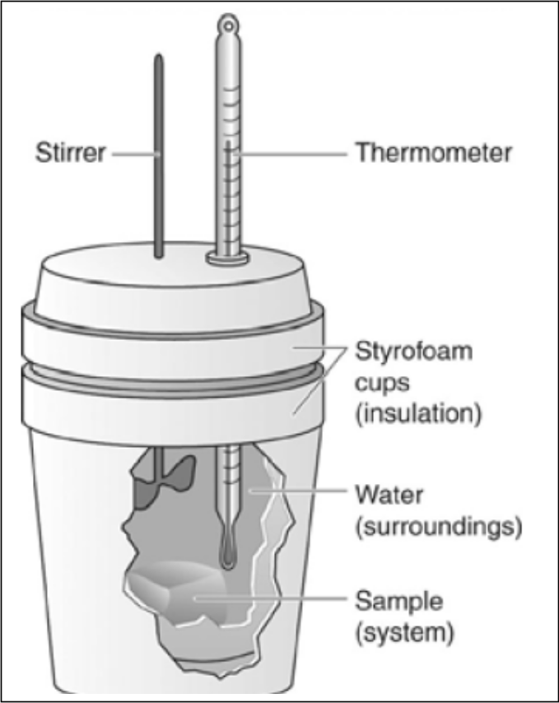
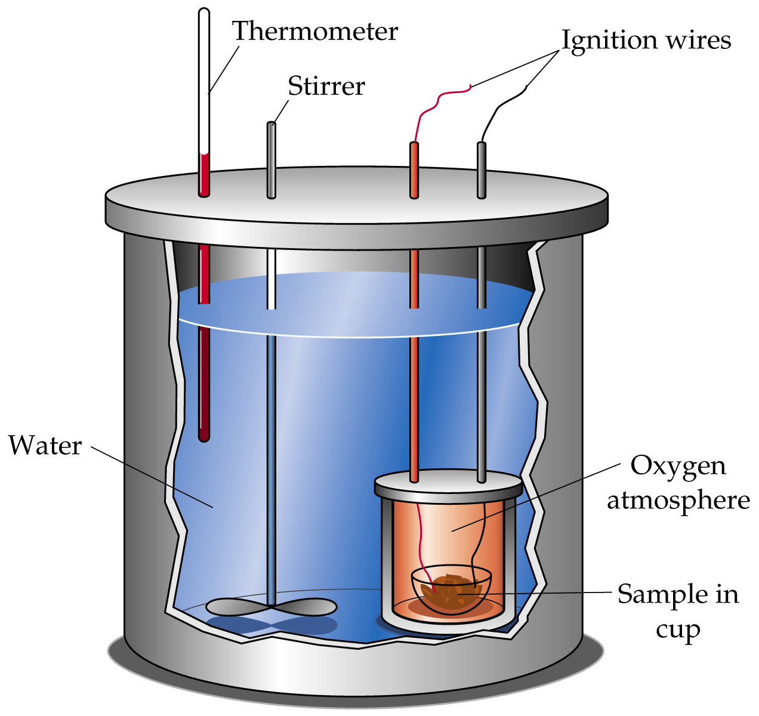

Limitations: Points:
- Cannot be used for reactions involving _____ - Reaction takes places in a sealed
- Cannot be used for ____ temperature reactions metal container
-Temperature difference of the
________ is measured
- Calculations are more complex because they must take into account heat flow through the metal container
Determining the Enthalpy of a Chemical Reaction

EXOTHERMIC: Q_{reaction} = -Q_{solution}
ENDOTHERMIC: -Q_{reaction} = Q_{solution}

- 50.0 ml of 0.300 M CuSO_{4(aq)} solution is mixed with an equal volume of 0.600 M NaOH_{(aq)} solution. The initial temperature of both solutions is 21.4ºC. After mixing the solutions in the coffee-cup calorimeter, the highest temperature that is reached is 24.6ºC. Determine the enthalpy change, ΔH, of the reaction and then write the thermochemical equation.
Hess’s Law of Heat Summation

Recall: Calorimetry is an accurate technique for determining enthalpy changes of a system.
- How do chemists deal with chemical systems that _________ be analyzed using this technique:
• Slow reactions
• Small changes in enthalpy
- The net changes in some properties of a system are independent of the way the system changes from the initial state to the final state.

What does this have to do with _____________ changes???
• If a set of reactions occurs in different steps but the initial reactants and final products are the same, the overall enthalpy change is the same.

Hess’s Law of Summation
For any reaction that can be written in a ___________, the standard heat of reaction is the same as the sum of the _______________ of reaction for the steps

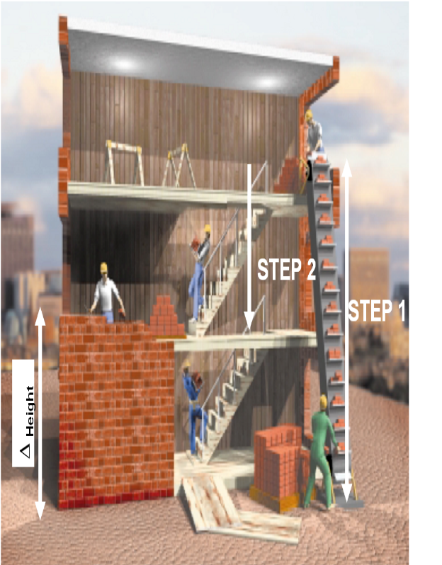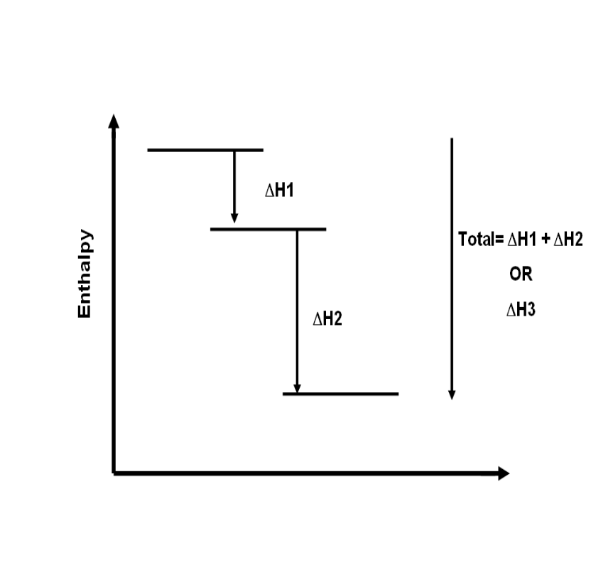

Combining and Manipulating Chemical Equations: A 7-Step process
1. Ensure ALL chemical equations are correctly balanced
2. Examine the given equations to see how they compare with the ___________
3. “________” equations to obtain reactants and products on the correct sides
-ANY time you Flip (or reverse) an equation you _______ multiple the associated enthalpy change by [-1]
4. ___________ coefficients in an equation by an integer or fraction if required
- ___________ the enthalpy value for this equation by the same factor
5. Write the manipulated equations so that their ___________ line up
6. Add reactants and products on each side, ______________ that appear on _____ ________
7. _______ the enthalpy changes for the combined reactions
** ALL equations need to add together to arrive at the TARGET equation**

Example 1
What is the enthalpy change for the formation of two moles of nitrogen monoxide from its elements? N₂(g) + O₂(g)  2NO_{(g)} !H° _ ?

(1) 1/2 N_{2(g)} + O_{2(g)}  NO_{2(g)} ΔH° +34 kJ
(2) NO_{(g)} + 1/2 O_{2(g)}  NO_{2(g)} ΔH°–56 kJ

Example 2
What is the enthalpy change for the formation of one mole of butane (C₄H₁₀) gas from its elements? The reaction is: 4 C_{(s)} + 5 H_{2(g)}  C₄H_{10(g)} ΔH° = _ ?

The following known equations, determined by calorimetry, are provided:
(1) C₄H_{10(g)} + 13/2 O_{2(g)}  4 CO_{2(g)} + 5 H₂O_{(g)} ΔH°- 2657.4 kJ
(2) C_{(s)} + O_{2(g)}  CO_{2(g)} ΔH° - 393.5 kJ
(3) 2 H_{2 (g)} + O_{2(g)}  2 H₂O_{(g)} ΔH°- 483.6 kJ

STANDARD ENTHALPIES OF FORMATION

- Reactions in which compounds are formed from their elements (in their standard states) are called _______________________.
E.g. C_{(s)} + O2(g)  CO2(g) ΔH°f = -393.5kj/mol
- ΔH°f = standard enthalpy of formation ** Table of values on p. 250, p. 597 **
- Always written for one mole of product.
- The product may be in any state but the reactant elements must be in their standard states.
- The standard enthalpy of formation of an element in its standard state is ______.
H_{2(g)}  H_{2(g)} ΔH°_{f} = 0

ΔH = Σ nΔH°f(products) - Σ nΔH°f(reactants)

EXAMPLE:
- Iron(III)oxide reacts with carbon monoxide to produce elemental iron and carbon dioxide. Determine the enthalpy change of this reaction,
___Fe₂O_{3(s)} + ___CO_{(g)}  ___CO_{2(g)} + ___Fe_{(s)}
RATES OF REACTIONS

The change in _________ of a reactant or product per unit ________. For example:

A + B → AB
Rate = decrease in [A] or increase in [AB]
change in time change in time
[ ]
time
Rates are usually determined at the __________ of the reaction due to the ___________amount of reactant present (max. collisions). The average or instantaneous reaction rate can be determined from a graph using the slope formula. e.g.

- Average rate = use first and last points
- Instantaneous rate = slope of tangent

Determining Average and Instantaneous Rates of Reactions Graphically
Instantaneous Rate of Reaction
- the rate of reaction at a particular time
- found using slope of ___________ (the best straight-line approximation to the
curve at a particular point. Only touches curve at one point)

Average Rate of Reaction
- the mean change in concentration of reactants or products per unit of time
- found by determining slope of __________ (a line that intersects two or more
points on the curve)

For the reaction: A_{(g)}  C_{(g)} + D_{(g)}
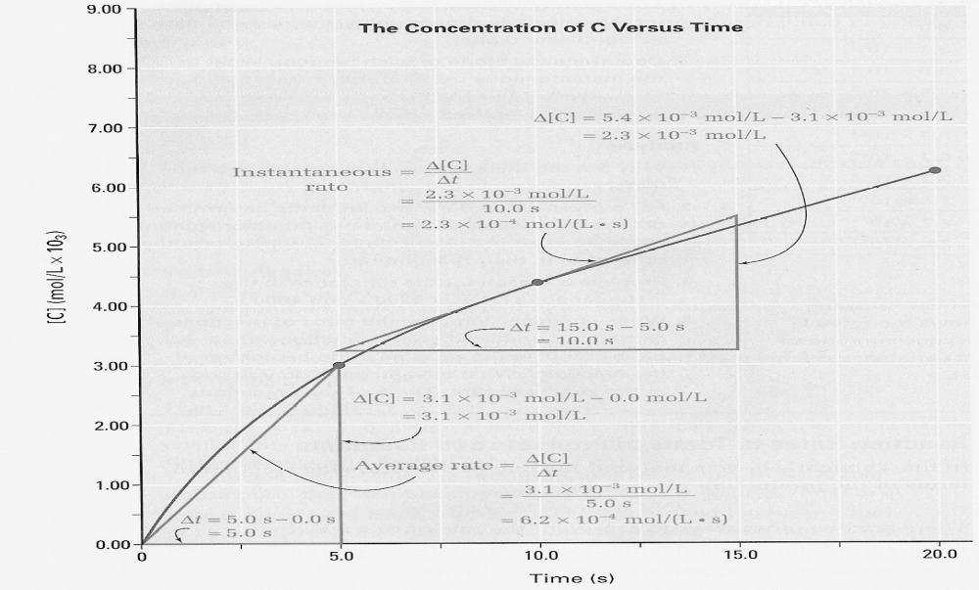

• For each line, a ___________ slope means a ____________ rate of reaction
• As the reaction proceeds the reactants are used up and the slope of the
tangent decreases, therefore rate of reaction decreases.

Reaction Rates in Terms of Reactants and Products

There are two ways to represent the rate of a reaction:

- Rate of disappearance of reactant
- Rate of appearance of product

For example;

___ N₂O₅ _{(g)} → ___ NO_{2 (g)} + ___O_{2 (g)} (balance first)

For every ____mol of O₂ produced ____mol of NO₂ is produced.

For every ____mol of O₂ produced ____mol of N₂O₅ are consumed.

EXAMPLE 2.
Consider the reaction:

1 IO₃⁻ _{(aq)} + 5 I⁻ _{(aq)} + 6 H⁺ _{(aq)} → 3I_{2(aq)} + 3H₂O_{(l)}

What are the rates of reaction with respect to the various reactants and products? The rate of reaction with respect to iodate ions (rate of consumption of IO₃⁻ ) is determined experimentally to be 3.0 x 10⁻5 mol/(L•s).

Influencing the Rate of Reaction
___________________ states that in order for reactions to occur molecules must collide.
- These collisions must be “effective” collisions, that is:
1. ______________ of molecules must be correct
2. There must be sufficient __________________________

Factors that Effect the Rate of Reaction
a. Temperature
- When two chemicals react, their molecules have to collide with each other with sufficient energy for the reaction to take place. By heating the mixture, you will raise the ___________ energy of the molecules involved in the reaction.
b. Concentration of Reactants
- Increasing the concentration of the reactants will increase the _____________ of collisions between the two reactants.
c. Catalysts
- A catalyst is a substance that lowers the amount of ____________________, (EA), necessary to initiate a chemical reaction, but is not consumed in the reaction.
d. Surface Area of a solid reactant
- If a solid particle is broken up, the surface area of the molecule is increased. Increased surface area means an increased number of possible _______ for reaction to occur.
e. Pressure of gaseous reactants & products
- By increasing the pressure, molecules are forced closer together which will increase the frequency of collisions between them.
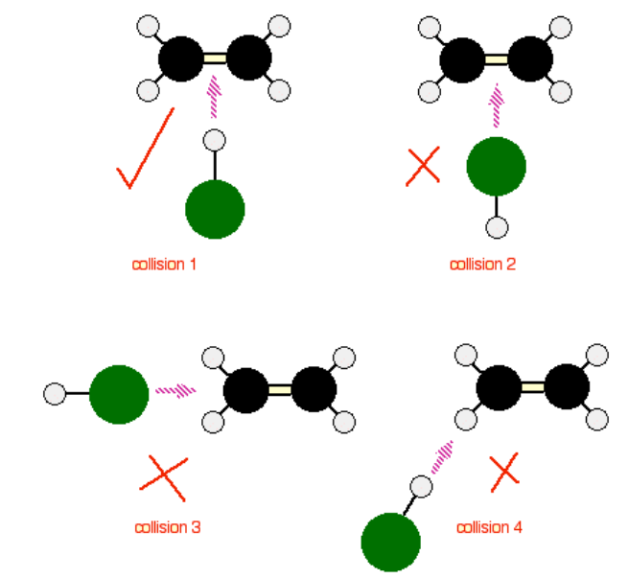
Activation Energy
Recall - For a reaction to occur:
a. particles must collide in a
specific orientation
b. particles must collide with
sufficient kinetic energy
- _______________ is the
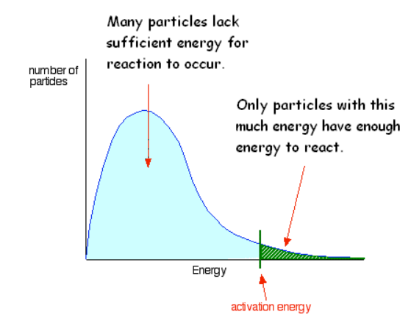
minimum collision energy
required for a successful
reaction to occur.
- Diagrams called ____________
__________________________
are plots of kinetic energy vs.
number of particles.
- As temperature
increases the kinetic
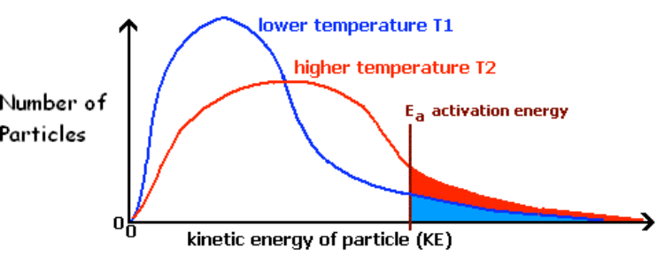
energy of molecules
increases. Therefore
more particles will have
sufficient energy
required to react.

Potential Energy Diagrams
- When molecules collide, kinetic energy of the particles is converted to ___________ energy. Potential energy diagrams are used to illustrate the change in potential energy during a reaction.
Exothermic reaction Endothermic Reaction
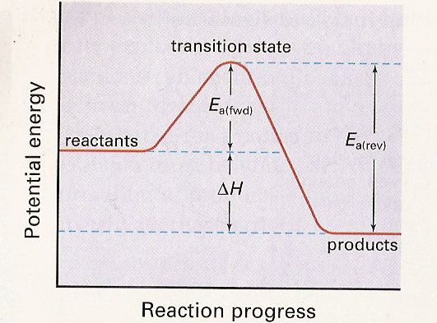
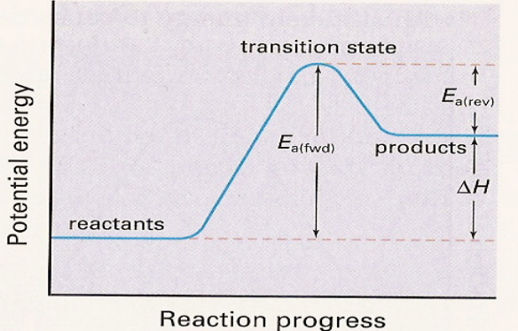

Diagram Terminology
- Ea – activation energy
- For an exothermic reaction: Ea_{(rev)} = Ea_{(fwd)} + ΔH
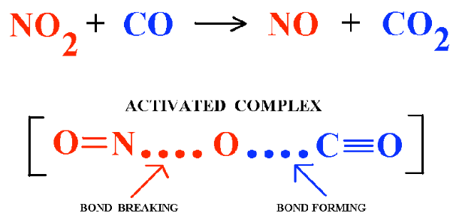
- For an endothermic reaction: Ea_{(rev)} = Ea_{(fwd)} - ΔH
- _________________ – point when reactants
are converted to product.
- _________________ – chemical species that
exist at the transition state. For example:

Questions:
1. It is a general rule that with a 10ºC temperature increase most reaction rates will
double. This is not the result of doubling the number of collisions. Explain.

2. Sketch a PE diagram for the following reactions. Include labels for Ea, ΔH, & transition state.
a. S_{(s)} + O_{2(g)}  SO_{2(g)} ΔH = -296.06 kJ
Catalysts

Recall: A catalyst is a substance that ____________ the rate of a chemical reaction without being ____________ in the reaction.
- A catalyst works by ___________ the activation energy of a reaction so that a _________ number of reactants have _____________ energy to react.
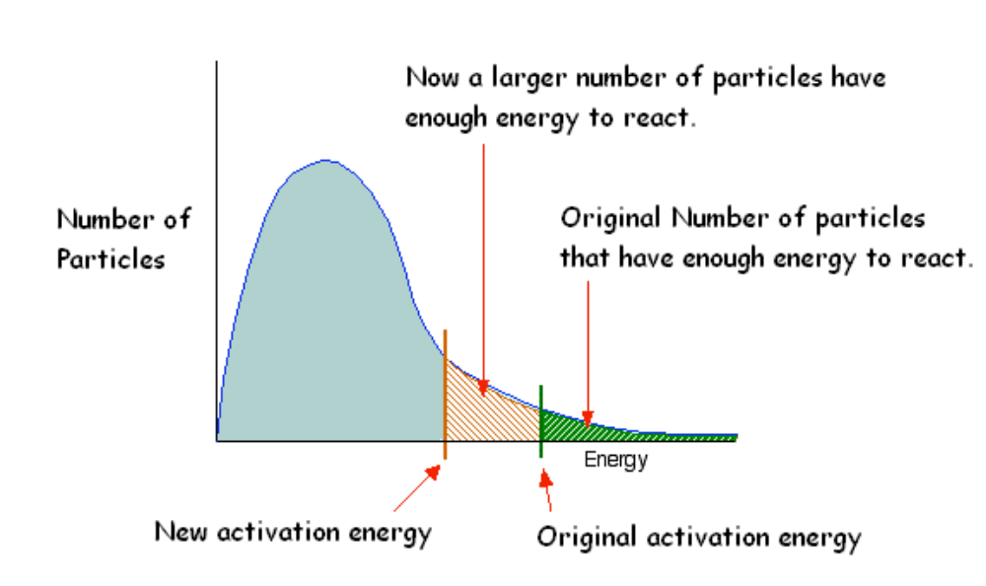

Potential Energy Diagram
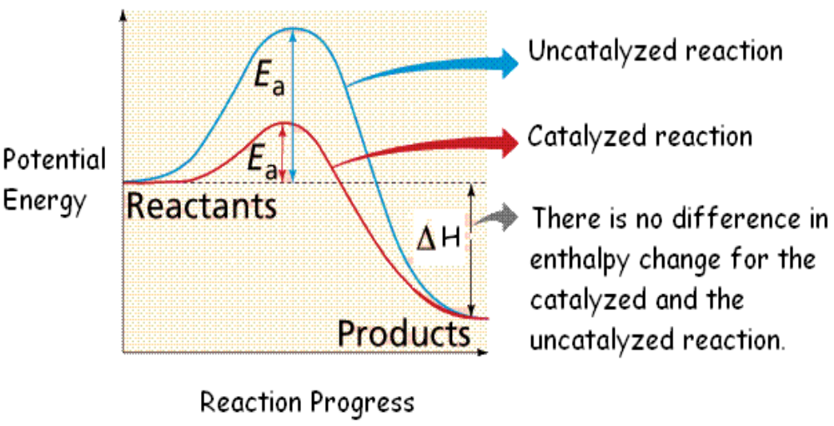

Homogeneous catalysts
- exist in the same phase as the reactants.
- most often catalyze gaseous & aqueous rxns
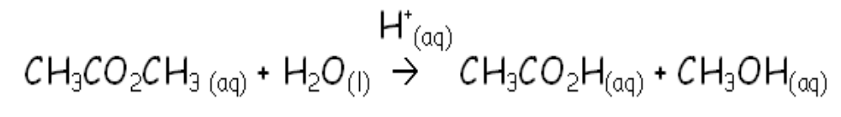

Heterogeneous catalysts
– exists in a different phase than reactants.
– without a catalyst this type is very slow
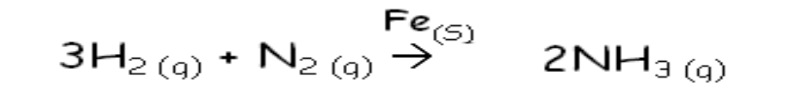

Enzymes
- Enzymes are organic catalyst used in biological reactions. In an enzymatic reaction the reactant molecule(s) are called the ___________ and the _____________ is the portion of the enzyme where the substrate binds to the enzyme.
Reaction Mechanisms
- Most reactions occur in a ____________ of steps.
- These series of steps are together are called a ________________________.
- Each individual step is called an _______________________.
- Molecules that form in one step and are consumed in the next are called _________ ________________.
For example this reaction occurs in two steps:
Overall rxn: 2 NO_{2(g)} + Cl_{2(g)}  2 NO₂Cl_{(g)}
Step 1: NO_{2(g)} + Cl_{2(g)}  NO₂Cl_{(g)} + Cl_{(g)} (slow)
Step 2: NO_{2(g)} + Cl_{(g)}  NO₂Cl_{(g)} (fast)

Each elementary step is classified according to number of reactants.
- Unimolecular – elementary reaction with one particle
- Bimolecular – elementary reaction with two particles
- Termolecular – elementary reaction with three particles (rare)

In an ___________
Elementary Reaction | Rate Law
A  products | Rate = k[A]
A + B  products | Rate = k [A][B]
2A  products | Rate = k[A]²
2A + B  products | Rate = k [A]²[B]

___________, the
exponents in the rate
law equation are the
same as the
stoichiometric
coefficients.

Elementary Reaction Rate Law
A reaction mechanism must:
1. contain equations that ____________ to give ___________ equation
2. contain _________________ elementary steps
3. support the experimentally determined ________________
- Each elementary reaction has its ________ rate.
- The _________ elementary reaction is called the _______________________.
- It is assumed that this ”slow” step by itself ____________ the rate of reaction.
- As a result the rate law for the rate-determining step is the rate law for the overall reaction.
- From the above example the first step is the __________________________. Therefore the rate law for the first step is the rate law for the overall reaction.
Rate= k[NO₂]¹ [Cl₂]¹

