Heat Transfer: Radiation, Conduction and Convection

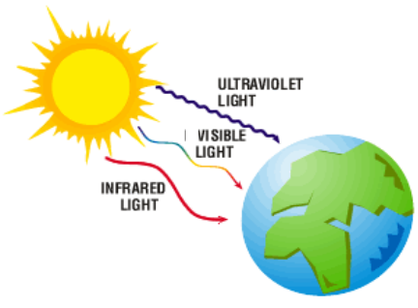
When radiation from the Sun (UV, IR, visible wavelengths) reaches the Earth, it is absorbed & reflected by the Earth’s surface. The Sun provides most of the Earth’s energy and along with the Earth’s natural _______________; our planet is able to maintain an average temperature of ____. It is the energy from the Sun that is the driving force behind all the ____________ and ___________ patterns on our planet.
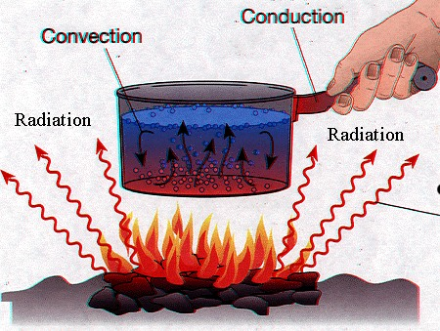

Transfer of Energy

______ energy is the energy of _____ of particles in a substance. _____ is thermal energy transferred from one substance to another. Energy can be transferred between two places by one of three methods:

Radiation
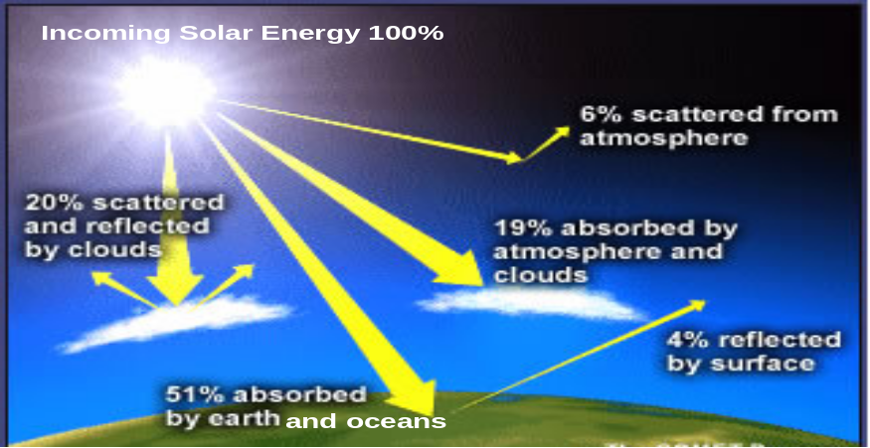

Radiation is the transfer of energy by means of ___________________. These waves do not require a _______. This is how the Sun’s energy reaches the Earth. When solar radiation penetrates the Earth’s atmosphere it can be either __________ or ____________.

Examples of radiation include holding your hand above a grill to check if it’s hot, spreading black coal on highways to melt surface ice and melt snow, using the shiny side of aluminum foil facing the food to reflect the radiant heat to cook the food faster.

Conduction
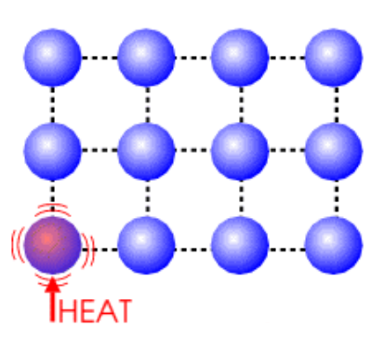

Conduction is the transfer of energy through the means of ________, mostly in ____. When highly energetic particles vibrate more quickly, they _______ with other particles and transfer some energy to them. Conduction occurs on Earth’s surface, in _____, ______, & ______. Conduction is only a small part of the transfer of energy in weather.

Examples of conduction include insulating material around hot water bottles to keep the heat in; a potato cooks faster with an iron nail in the middle of it since the heat conducts along the nail to cook the potato from the inside out.

Convection

Convection is the transfer of energy by the movement of molecules in a _______ (______ or _____). Convection is the most important concept for weather systems, since they depend on the movement of ________________________ to create _______________.

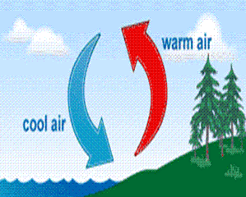

A convection current is set-up when particles of a fluid gain energy. As their movement increases, the particles _____________ and that portion of the fluid becomes _________ compared to its surrounding; thus it _______. The warm fluid is replaced by cooler fluids as the flow of the convection current begins.

Examples of convection include holes on the top of a metal lamp shade, heating vents on the floor and not on the ceiling because hot air rises.

Movement of Air and Water

Air pressure is the pressure the air exerts as _________ pulls it toward the centre of Earth. At sea level, there’s approximately ______________ of atmospheric pressure.

A ___________ is the instrument used to measure pressure. An aneroid barometer is the most common type, consisting of a sealed metal container. Small changes in atmospheric pressure cause the container to expand or contract, changing the needle position and registering the change in pressure.
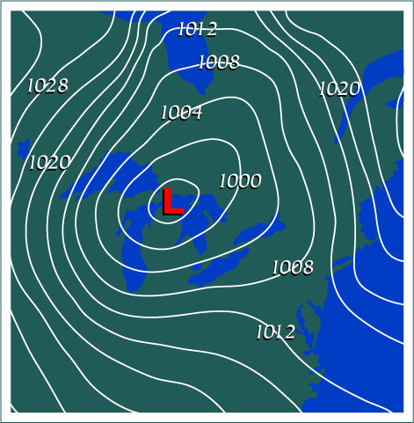
Pressure gradients are used to measure the amount the atmospheric pressure changes across a set distance.

Vertical gradients measure changes in pressure with changes in altitude, and influence convection. They have the most variations.

Horizontal gradients measure changes in pressure along the same altitude and influence pressure systems (H, high pressure, L, low pressure). They lead to the movement of air called wind. Horizontal gradients can be used to determine the strength and direction of winds.

On a map, areas with the same pressure can be connected with a smooth line.
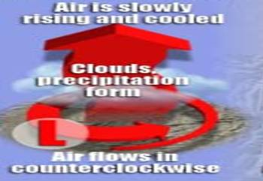
Pressure systems

Low Pressure System
An “L” on a weather map indicates a low pressure system, meaning that the area has a decrease in atmospheric pressure. _______ air is less dense and _______ to create low pressure systems. Any air that was pushed up will swirl in a _____________ direction due to the Earth’s ___________ (Coriolis effect). As warm air rises, it is cooled and condensed; therefore low pressure systems bring ____________ and ________________________.

High Pressure Systems
An “H” on a weather map indicates an area of high pressure. A high-pressure system means the pressure inside the system is higher than that of the surrounding areas. This is because ______________ air is more dense and ________. Since warm air is able to hold more water vapor the high-pressure system is usually associated with _______ weather as clouds do not form. Air will move _____________ in a high pressure system as it moves outward towards areas of low pressure.
Air Mass

An air mass occurs when ____________________________ in an area for long enough to take on the temperature and moisture characteristics of the land or water below.
Example of air masses include continental polar (cold and dry) or maritime tropical (hot and wet).

Fronts

A front is formed when ___________________. There are many times of fronts, the most common being a warm or cold front.
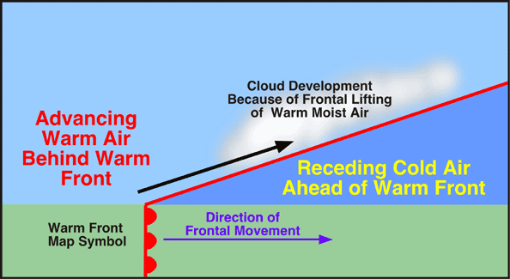
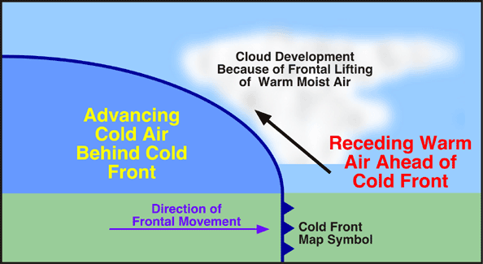

Winds
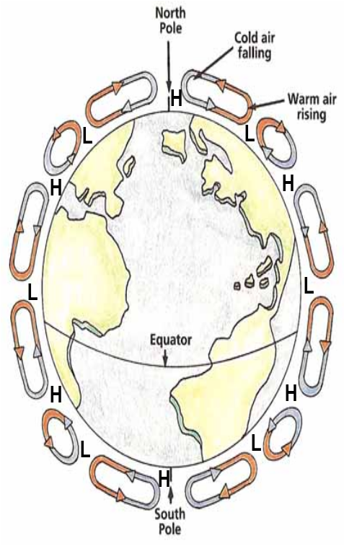

Wind is a result of pressure differences between areas, since air wants to move from areas of _____ pressure to areas of ______ pressure.

Near the Equator, the Sun heats the Earth with the greatest intensity. When an area of Earth’s surface is heated, the air above it is warmed which causes it to rise and move towards the Poles.

As warm air rises, it cools off since it gets farther away from the warm Earth, therefore it becomes more dense than the warm air, falls back towards the surface and moves to replace the warm air from the Equator.

The circular current formed by the rising warm air and falling cool air is a convection current. This pattern of convection currents is repeated closer to the poles, creating three closed sets of convection currents (called cells) at approximately 0º, 30º, and 60º latitude.

Wind patterns can be understood as the combination of the convection currents previously described and the Coriolis effect; the deflection of objects caused by the Earth’s rotation from ____________. Wind is named with respect to the direction that it originated from (ex. wind from BC to Ontario is moving East, but it is coming from the west therefore it is called “west winds” or “______________”)

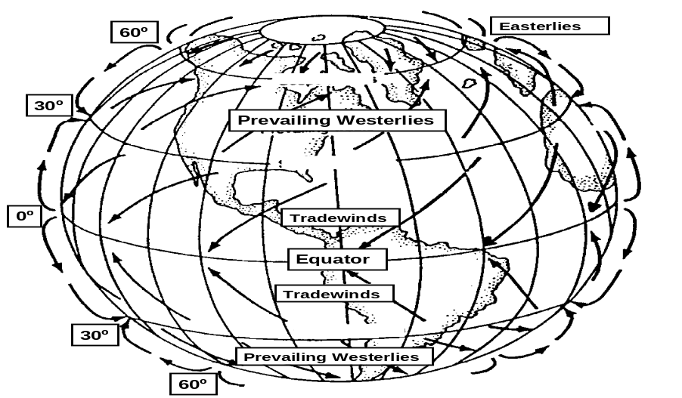
The _____________ is a ribbon of extremely fast moving air near the top of the troposphere caused by the contact of cold and warm air masses. The polar jet stream forms at the boundary between the warmer prevailing westerlies and the cooler polar easterlies.

Ocean Currents

Ocean currents are ___________________ and are important for weather and climate since they occupy so much of the Earth’s surface. Ocean currents patterns can be explained by:

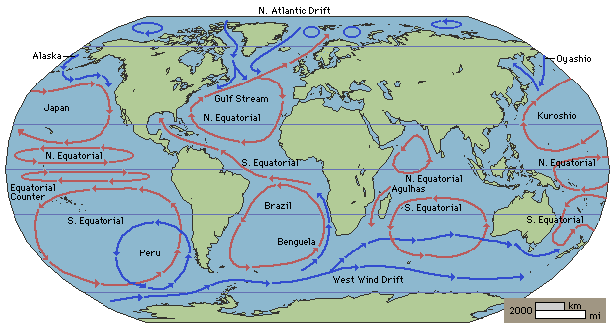

Weather vs Climate
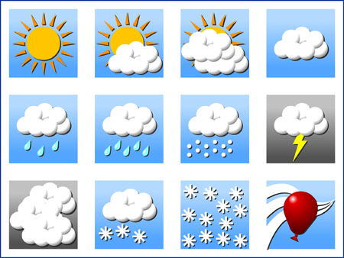
What is weather?

Weather includes all of the atmospheric conditions that occur over a ________________ of time (i.e., an hour, day, or week).

_____________ are scientists who study the weather, and use the following information to describe the weather:

In some areas the daily weather is the same, like the Sahara Desert where it is always hot and dry. In Canada, the weather changes, sometimes dramatically from day to day. Weather data has been collected since the 1800’s, using weather stations, weather balloons, aircraft, and satellites.

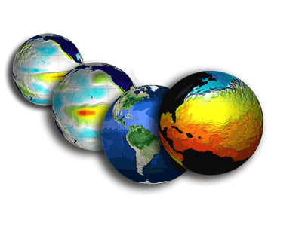
Interactions between water, air and land on Earth and energy from the Sun all contribute to weather.

What is climate?

Climate is the usual, or average, pattern of weather in a region ___________________________________.

____________ are scientists who collect weather measurements made over ___ years or more and average the results to study the climate.

The climate of a region gives a range of temperatures that would be expected at a certain time of the year, and whether you can expect rain, snow, or high winds in certain seasons. The climate of a region determines the weather you can expect over many years.

“Climate is what you expect, but weather is what you get”
–Robert Heinlein

Classifying Climate

_____________ have been identified since the early 1900's using ______________, ___________ and ________________. Wladimir Koeppen identified 5 climate zones, each is subdivided further into ________________.

The 5 climate zones are:
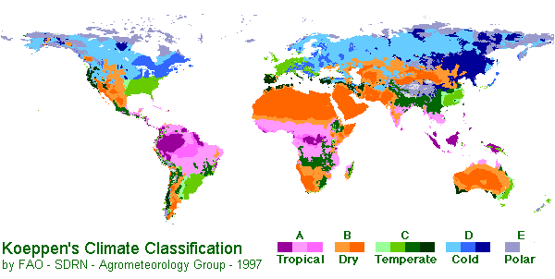
Moderate
Continental

A graphic representation of an areas expected climate data is called a _____________. Climatographs are useful because they allow scientists to view how temperature and precipitation change throughout the year and to compare weather patterns in different locations.

Factors that Affect the Earth’s Climate:

The amount of solar energy that reaches the Earth’s surface depends on a number of factors:
________________________ - the amount of energy produced by the Sun fluctuates by about 0.1% every __ years (“sunspot cycle”).
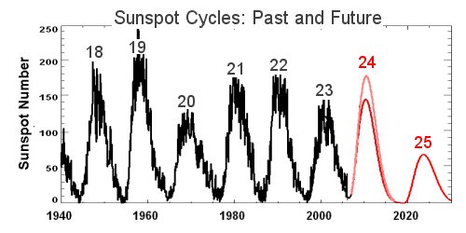

______________________________ - Earth’s axis of rotation is tilted at an angle of about ____. This, combined with its annual orbit around the Sun, produces our seasons.
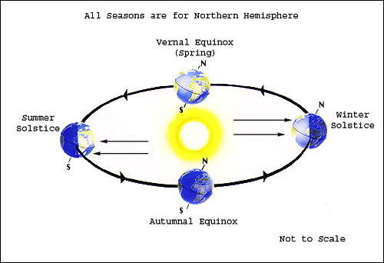

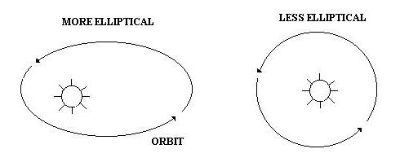
__________________________________ - change in shape of the Earth’s orbit due to the gravitational pull of the other planets (_________) is a __________ year cycle.

___ - the angle of the Earth’s tilt varies by about 2.4^{O} ; a greater degree of tilt means greater temperature differences between summer and winter (______ year cycle)

__________ - the Earth is not a perfect sphere, it wobbles slightly as it rotates (like a wobbly top). This determines whether the two hemispheres (N & S) will have similar contrasts between seasons, or if one will have greater differences than the other.
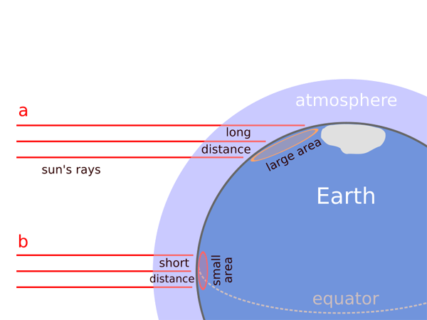

_________ - because of the spherical shape of the Earth, areas close to the equator receive more direct, intense sunlight than areas closer to the poles.

Earth’s atmosphere extends _____ up from its surface, and is composed mainly of N₂, O₂, and CO₂ gases.

The ____________________ is a natural part of Earth’s climate system which helps keep temperature fluctuations within a certain range.

The movement of air from areas of ____ to ____ pressure (a.k.a. “_____”) transfers energy around the world and affects the ocean currents and precipitation patterns. Wind is caused by the uneven heating of the Earth’s surface and the rotation of the Earth (_________________).

Oceans and lakes act as “heat reservoirs” (they hold in heat) because water has a high _________________________

Ice and snow reflect heat because their light colour increases their _______ (ability to reflect light). ______ ice and snow would result in _____________ of radiant energy.

The Earth's out layer is composed of massive pieces of sold rock knows as _________ _________. Tectonic plates move a few _____________ each year. This affects air and water circulation which transfer energy around the globe.

________________ release ash and other particles which _______ radiation and have a _______ effect on the climate. The 1815 eruption of Tambora in the Philippines cause the “Year Without Summer.” Some types of volcanic eruptions may _______ global temperatures by releasing _____________ gases.

The current change in climate is at least partly ___________________ (relating to or resulting from the influence of humans). The _________________ started in the late 1700’s/early 1800’s. New machines were invented to do work for us by burning _______ ______ (automobiles, trains, ships, aircraft, factories, farming/mining equipment, furnaces, etc...) When fossil fuels are burned to release _______, they release ______ and other _____________ into the atmosphere as a waste product. Many of these gases affect the natural process that produces the greenhouse effect.
The Greenhouse Effect

Earth’s climate system maintains Earth’s temperature by _____________________ energy from the Sun and distributing the energy around the world.

- A lot of the ____________ radiation from the Sun that passes through the atmosphere is absorbed by the Earth’s surface, and as a result, the Earth’s surface ____________.

- The Earth emits _____________________ radiation (IR), which is trapped by the _____ in the atmosphere.

- Atmospheric gases then radiate the energy in all directions, which means that about _____ of the radiation gets sent back toward Earth’s surface warming the Earth even more.

- The Greenhouse Effect is a natural process in which gases and clouds _______ IR emitted from Earth’s surface and radiates it, heating the atmosphere & Earth’s surface. It is the phenomenon that keeps temperatures on our planet consistent during the day and night.
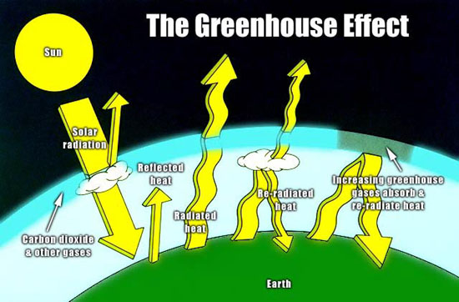

Greenhouse Gases

- Most of the atmosphere is ___________ (78%) and __________ (21%) neither of which absorbs radiation from the surface of the Earth.

- The greenhouse effect is caused by the gases that make up ________________ of the atmosphere, called the _______________________.

- The contribution of a greenhouse gas to the greenhouse effect depends on its ________________ in the atmosphere and by how much ____________________ each molecule of gas can absorb.
1) Water vapour, H₂O_{(g)} – accounts for ____ of the natural greenhouse effect. The concentration of H₂O in the atmosphere is temperature dependent and ranges between ________ amounts and ____ of the atmosphere. As Earth’s temperature increases, more liquid water becomes water ________ and the ________ air can hold more water vapour. Water vapour can ______________, which further heats up the Earth. This is a ______ feedback loop.
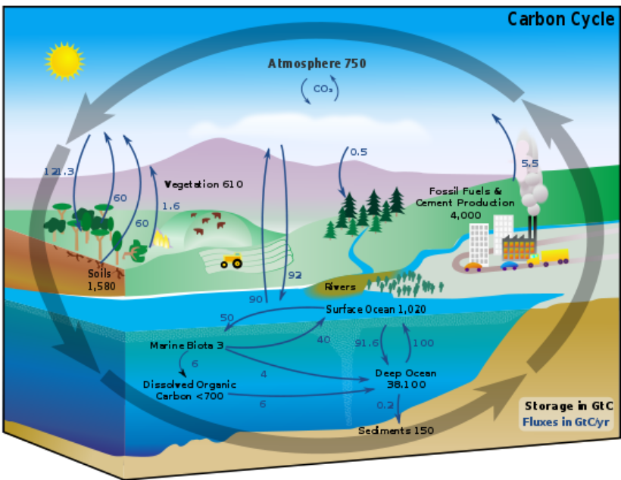

2) Carbon Dioxide, CO_{2(g)} – accounts for _________ of the atmosphere, but is thought to account for ¼ of the natural greenhouse effect on Earth. Since the _____________, the concentration of CO₂ has increased from _____________ ______. Natural sources of CO₂ include __________________, and _____________________.

The ________________ is the movement of carbon between the lithosphere, hydrosphere, atmosphere and living things. ________________________ are important _____________ in that they remove CO₂ from the atmosphere and convert it to other forms of carbon.

3) Methane, CH_{4(g)} – even though there is much less methane in the atmosphere than H₂O or CO₂, the methane molecules ________________ thermal energy than a molecule of CO₂. This makes methane _________ more powerful than CO₂ as a greenhouse gas. Since the Industrial Age, the methane concentration has increased from _________________. It is formed by natural sources such as ________________ in swamps and ____________.
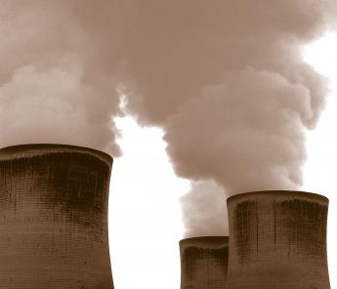
- Ozone, O_{3(g)} – Naturally, ozone is found in the ____________ where it protects the Earth from ___ rays from the Sun. Ozone is found in the __________________ in varying concentrations, and here it acts as a greenhouse gas.

- Nitrous Oxide, N₂O_{(g)} – N₂O molecules radiate much more energy than other greenhouse gases, it is almost ___________ more effective than CO₂. This ability of N₂O to trap high levels of energy is balanced by its extremely _____________________ in the atmosphere. The concentration of N₂O has increased from ____________________ since the industrial revolution. It is produced by natural sources such as _______________, and is also a _____________________.
What is the Enhanced Greenhouse Effect?

When there is a change in the amounts of the greenhouse gases there can be a disruption in the __________ of the climate system. This causes the Earth’s temperature to ________.

GLOBAL WARMING is the __________ in the ________ temperature of Earth’s near-surface air and oceans sine the mid-20th century and its projected continuation.

CLIMATE CHANGE is the ______ in the statistical distribution of ______ over periods of time that range from decades to millions of years. Climate change is a result of global warming!!

What are the sources of the Greenhouse Gases?

“There is new and stronger evidence that most of the warming observed over the last 50 years is attributable to ____________” (Intergovernmental Panel on Climate Change, January 2001)

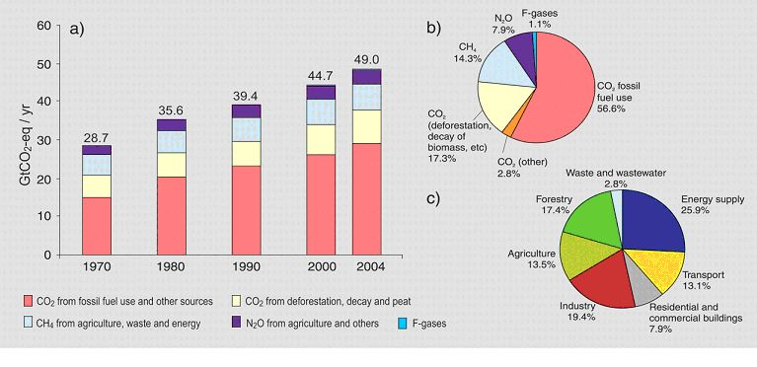
Evidence points to an increase in the greenhouse gases, H₂O, CO₂, CH₄, N₂O, which accounts for ___________________________.
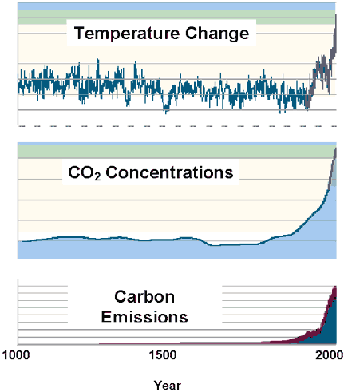
There is a strong correlation between the atmospheric ____ concentrations and global temperature ____________.

Relatively small changes in average temperatures can have huge consequences. During the last Ice Age, about 20 000 years ago, average temperatures were __________ than they are today, but the _________ were only ________ colder.

Evidence of Global Warming

- Earth’s climate has always changed over time
- Recent changes have not been experienced for _______________________.
- This time, scientists believe changes are happening because of _____________________ (__________________________).

Rising Temperatures
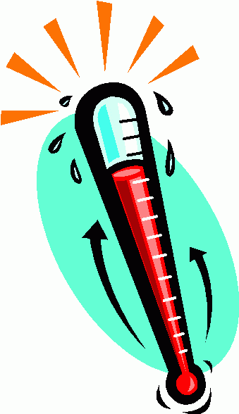
- Daily temperatures have been recorded since the 1800’s
- Annual average temperature each year can be graphed
- By 2006, ___ of the previous ___ years, was the __________________. ______________ has warmed up by ____ in the past ____ years.

Rising Sea Levels

- Sea levels have been rising almost _______ as fast as during previous warm periods, this can result in _________________________.
- Melting glaciers can cause sea levels to ______.
- As water temperatures increase, it ____________________________
- Water may be coming from North America, where levels of ___________ have dropped ________________.
- If the ice sheet covering Greenland were to melt, sea levels would rise _________.
- An increased amount of water in the oceans has changed the ___ from ____ to ____.
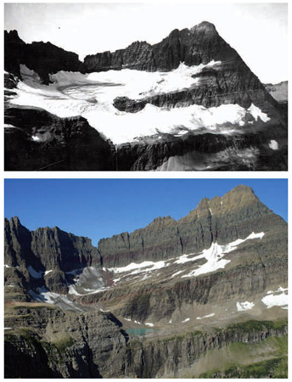
Melting Glaciers and Ice

- Average size of glaciers is ________ as global temperatures ___
- Water from melting glaciers runs to the oceans, provides fresh drinking water for almost _____ of the world’s population.
- If glaciers disappeared, there would be a ___________________.
- Ice and snow in the polar regions (Antarctica, Greenland) is melting.

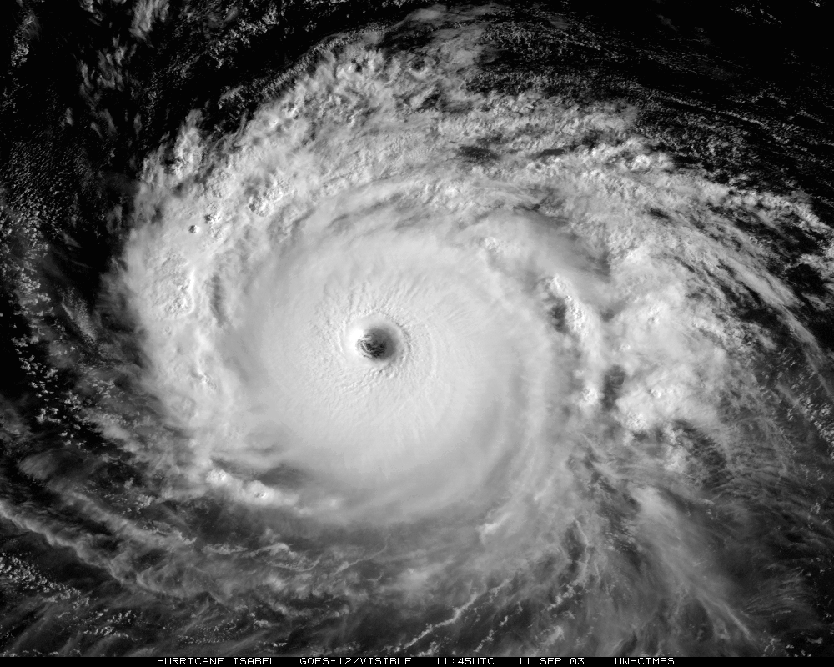
Severe Weather

- _______________________ are becoming more intense; a massive heat wave in Europe (2003) caused 1000’s of deaths not to mention the destruction of Hurricane Katrina (2005)
- Warmer ocean temperatures lead to more _______ hurricanes, there are ______ the number of category 4-5 hurricanes in the last _________

Precipitation

- Rising temperatures means more ____________________.
- The precipitation is heavier, with ___________________________.
- There are increasing levels of precipitation in some areas such as ______________, and less precipitation in drier areas such as __________

Changing Seasons

- Seasons are ______________________.
- Less cold days worldwide, and frosty nights _________ and ending ___________.
- Many areas have ________________________, beneficial for farmers.

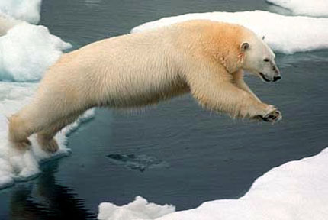

Changing Ecosystems

- Many trees, shrubs and other plants are ___________________ earlier than usual.
- Animals are _______________ earlier.
- Animals and plants are slowly _______ toward _____ and _____________________ as these areas warm up, changing ecosystems. This can lead to problems if the insects and plants are pests.


